**ARITRA MAZUMDAR**

**Roll No.- CSUG/172/17**

**DATABASE STRUCTURE**

**1. BOOK**

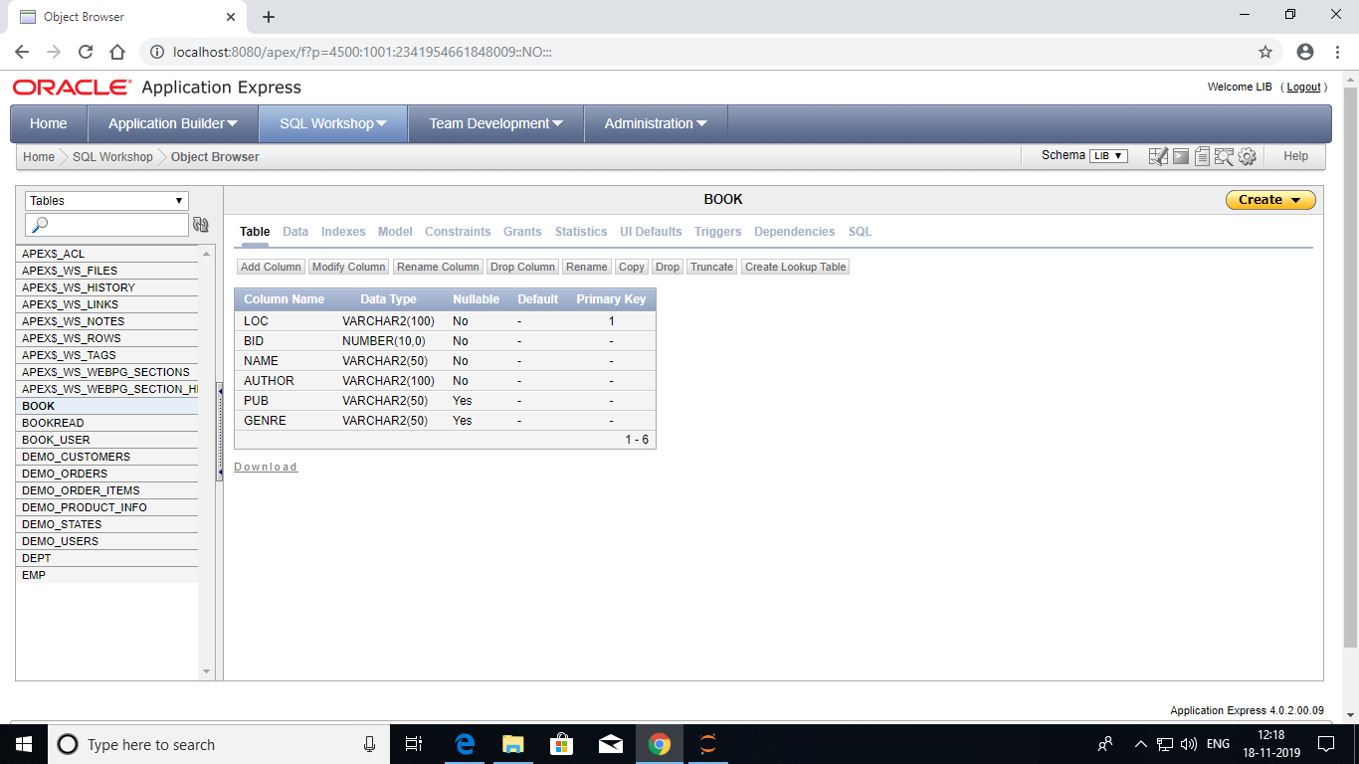

**2. BOOKREAD**

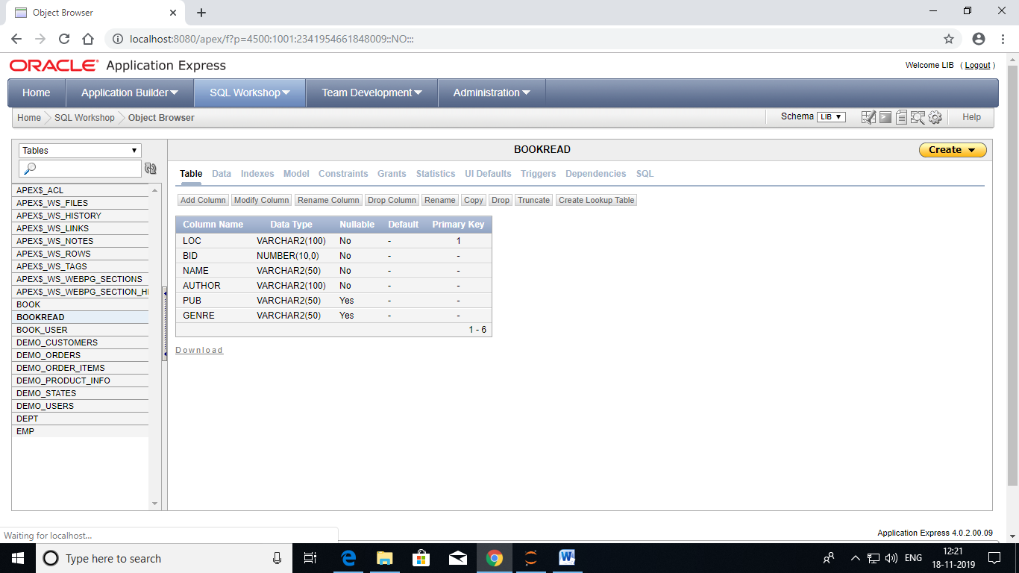

**3. BOOK_USER**

